ANGIELSKI W LUTYM
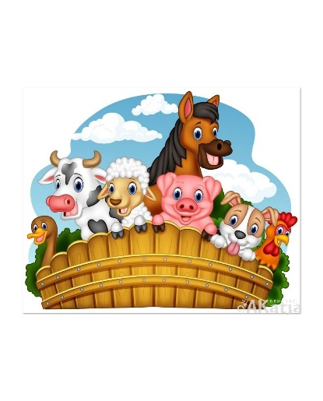
ANIMALS

Pets: dog, cat, rabbit

Farm animals: cow, horse, pig, sheep, duck

FAMILY
Mummy, daddy, brother, sister, baby

The finger family .-song
https://www.youtube.com/watch?v=nx04-iP7Rns
,,Daddy finger, Daddy finger,
Where are you ?
Here I am, here I am!
How do you do?”
,,Mummy finger, Mummy finger,
Where are you ?
Here I am, here I am!
How do you do? ”
Brother finger, Brother finger
Where are you ?
Here I am, here I am!
How do you do? ”

Sister finger, Sister finger
Where are you ?
Here I am, here I am!
How do you do?

Baby finger, Baby finger,
Where are you ?
Here I am, here I am!
How do you do?

